**QSMART – QSWITCH ELECTRIC ASSY REPLACEMENT**

**PROCEDURE**

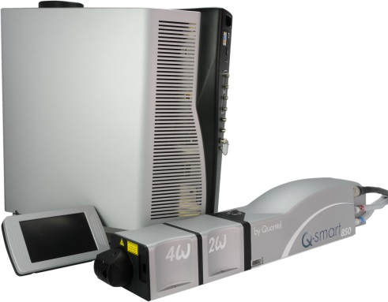

**Toolkit:**

Allen Keys kit

**System**: QSMART

|  |  |  |  |  |  |  |
| --- | --- | --- | --- | --- | --- | --- |
| |  |  | | --- | --- | | **SM010353** | **Q-SMART QSWITCH ELECTR ASSY** | |  |  |  |  |
|  |  |  |  |  |

**Purpose**: This document details how to change the QSWITCH electric assembly

|  |  |  |
| --- | --- | --- |
| Revision | date | modification |
| Initial issue | July 4, 2014 |  |
|  |  |  |
|  |  |  |
|  |  |  |

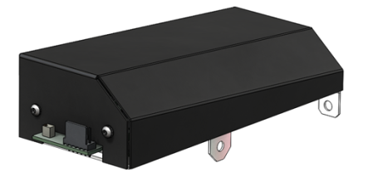

# DISASSEMBLING

* Turn the system off
* Disconnect cables and water hoses from the laser head side
* Remove the laser head cover.
* Remove the side plate (7 BHC 3x6)

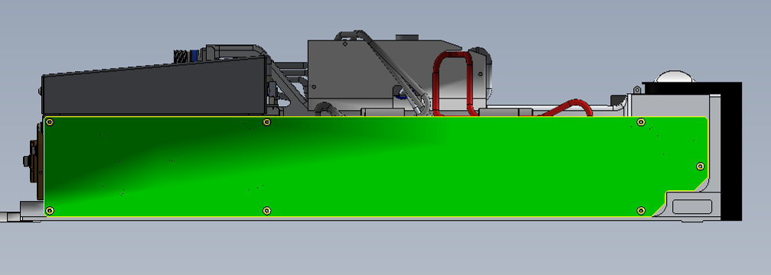

* Remove the ground wire (1), remove the power connector on the card Q Switch (2) and remove the connectors on the pockels (3)

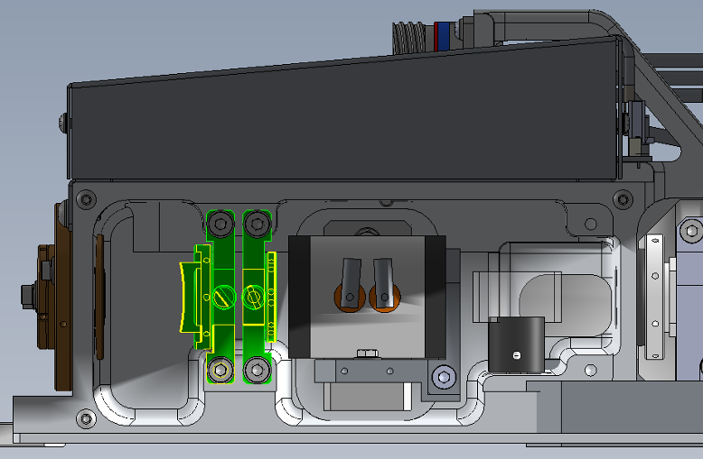

Position1 & 2

Position3

* Remove the unit from the foundry (3 screws)

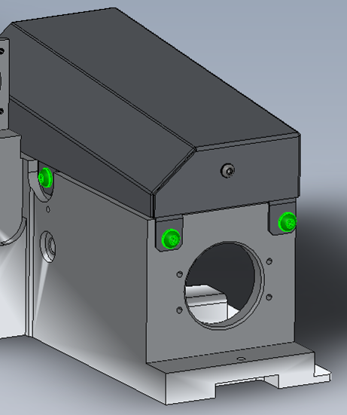

# INTEGRATION OF THE QSWITCH ELECTR ASSY

|  |  |  |
| --- | --- | --- |
| 1.00 | V/BHC-M0306A4 | BHC3X6 SCREW |
| 1.00 | R-DEC-D03-- | LOCKING 3 WASHER |



* Fasten the unit to the foundry (3 screws BHC4x10 + 4 ZU4 washers)
* Reinstall the ground wire (1), connect the power connector on the card Q Switch (2) and the connectors on the pockels (3)



Position1 & 2

Position3



* Fasten the side plate (7 BHC 3x6)
* Close the Laser head and put warranty stickers   
  *Refer to "LH-Warranty Labels"*